 | ELEC 205  Assignment 3  Sequential Circuit Design
 | Deadline: May 11, 11:59 PM
 | Name and Surname: Ahmet Buğra Ertürk
 | ID: 86877
Task 1
I draw the diagram in Figure 1 with 5 states (A/00, B/00, C/00, D/10, E/01). In these states the most significant bit shows Z₁, and the least significant bit shows Z₀.
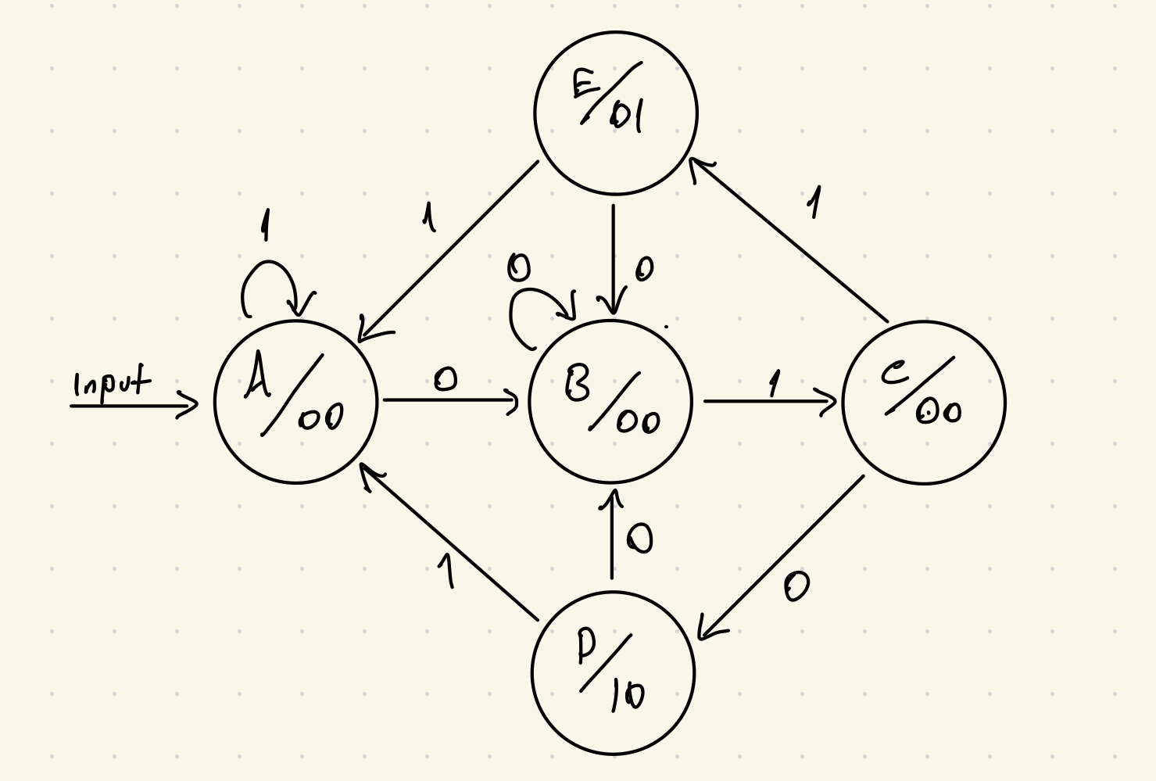
Figure 1

Task 2
Because we have 5 states, we need at least 3 binary digits to represent states. I represented the states with the binary codes in Table 1. Unused binary codes are treated as don’t care condition (x).

State | Binary Code (S₂S₁S₀)
A | 000
B | 001
C | 010
D | 011
E | 100
Table 1

Task 3
The state transition table is in Table 2 with unused state binary codes as don’t care conditions.
Present State (S₂S₁S₀) | Input (X) | Next State | Output (Z₁Z₀)
A (000) | 0 | B (001) | 00
A (000) | 1 | A (000) | 00
B (001) | 0 | B (001) | 00
B (001) | 1 | C (010) | 00
C (010) | 0 | D (011) | 00
C (010) | 1 | E (100) | 00
D (011) | 0 | B (001) | 10
D (011) | 1 | A (000) | 10
E (100) | 0 | B (001) | 01
E (100) | 1 | A (000) | 01
x (101) | x | x | xx
x (110) | x | x | xx
x (111) | x | x | xx
Table 2
Task 4
To see Boolean expressions of state binary codes and outputs explicitly, I created K-Maps below.
- S₀⁺ = $\sum{m(0,2, 4, 6, 8)}$, $\sum{d(10,11,12,13,14,15)}$
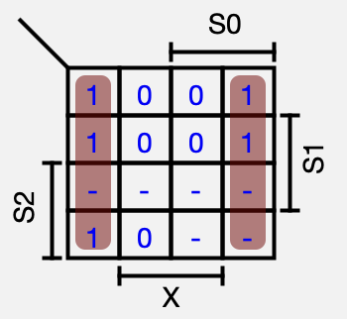
Figure 2
  - S₀⁺ = X’

- S₁⁺ = $\sum{m(3, 4)}$, $\sum{d(10,11,12,13,14,15)}$
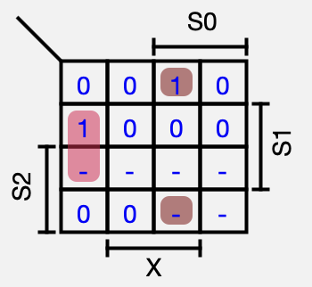
Figure 3
  - S₁⁺ = S₀’S₁X’ + S₀S₁’X = NAND (NAND (S₀’, S₁, X’), NAND (S₀, S₁’, X))

- S₂⁺ = $\sum{m(5)}$, $\sum{d(10,11,12,13,14,15)}$
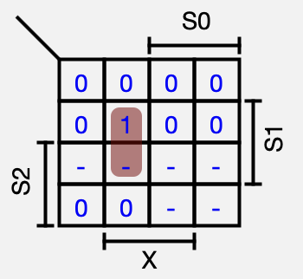
Figure 4
  - S₂⁺ = S₀’S₁X = NAND (NAND (S₀’, S₁, X), NAND (S₀’, S₁, X))

- Z₀ = $\sum{m(8, 9)}$, $\sum{d(10,11,12,13,14,15)}$
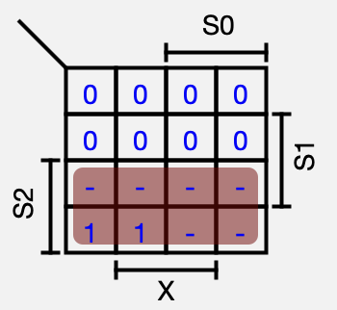
Figure 5
  - Z₀ = S₂

- Z₁ = $\sum{m(6, 7)}$, $\sum{d(10,11,12,13,14,15)}$
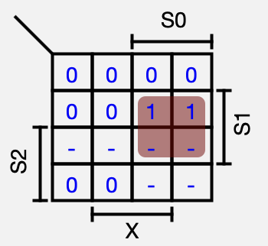
Figure 6
  - Z₁ = S₀S₁ = NAND (NAND (S₀, S₁), NAND (S₀, S₁))

These K-Maps help us to generate explicit Boolean expressions of state binary codes and outputs using only NAND gates. Now we can draw the circuit in Task 5 using D flip-flops to represent each binary code of states and NAND gates as the expressions that we found in this task.

Task 5
I created the circuit in Figure 7 according to expression which I found in Task 4.
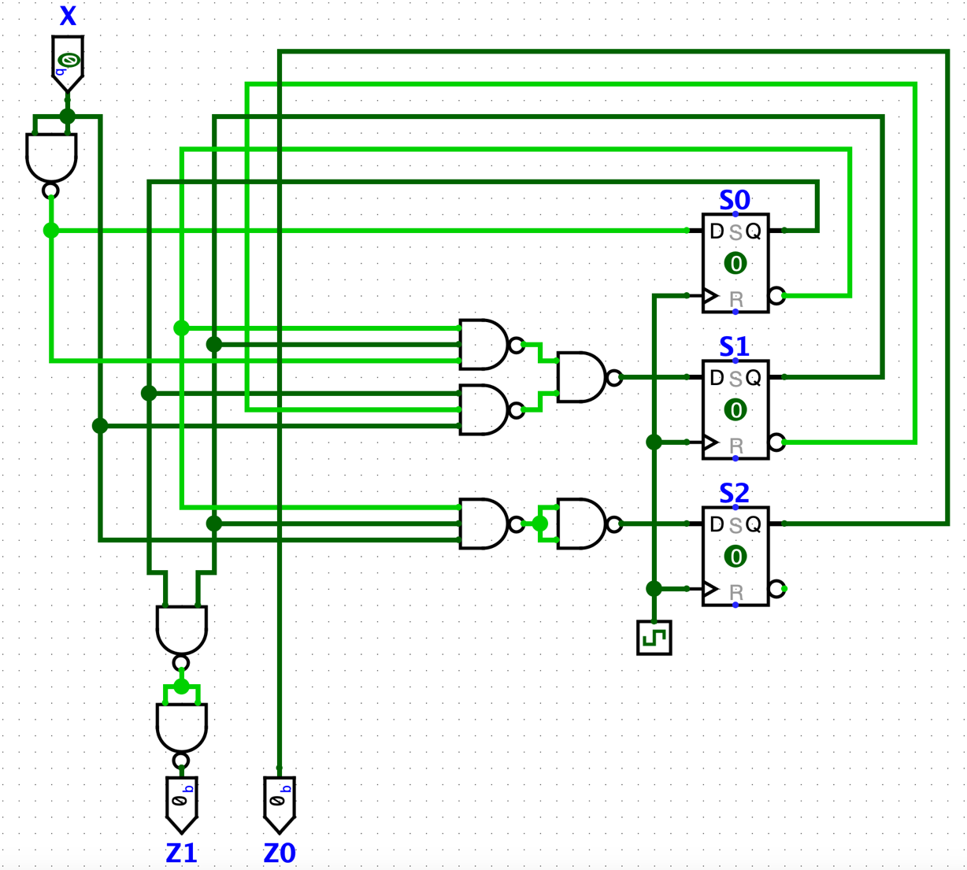
Figure 7

Task 6
The timing diagram contains 20 consecutive clock cycles with 3 (0 →1 →0) patterns and 3 (0 →1 →1) patterns as you can see in the diagram. Because of the structure of the D flip-flop in Logisim, which is Edge-Triggered, our states’ values changes only when clock is 1 since slave of the D flip-flop is clock value 1. At the same time master of the D flip-flop is clock value 0, so when we determine the pattern, we have to check the X values when the clock is 0.

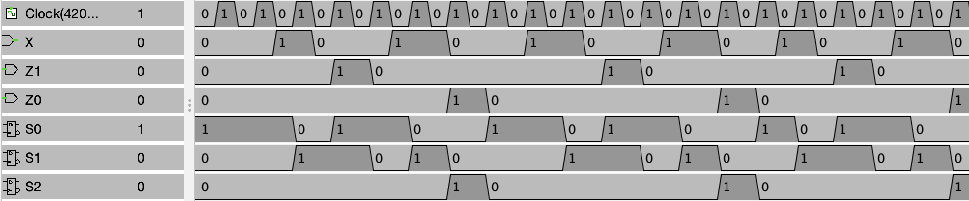
Figure 8

When we check the timing diagram in Figure 8 according to my explanation in previous paragraph, output of the timing diagram seems correct.

